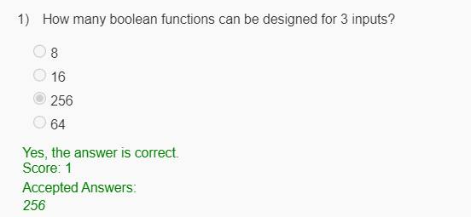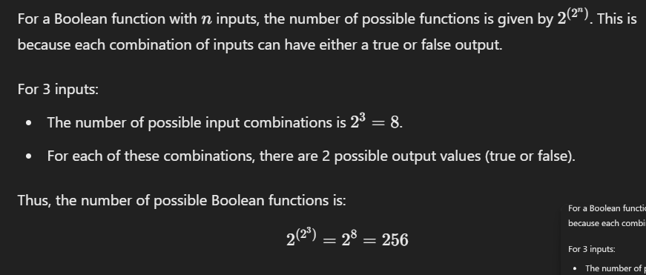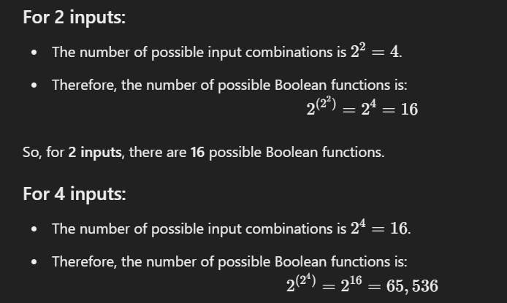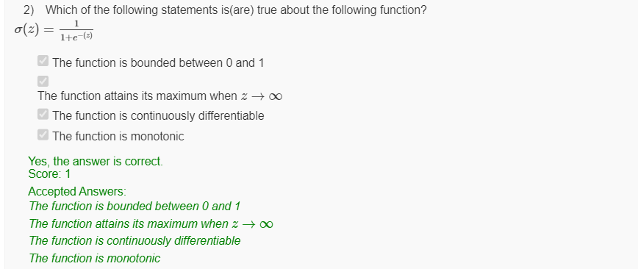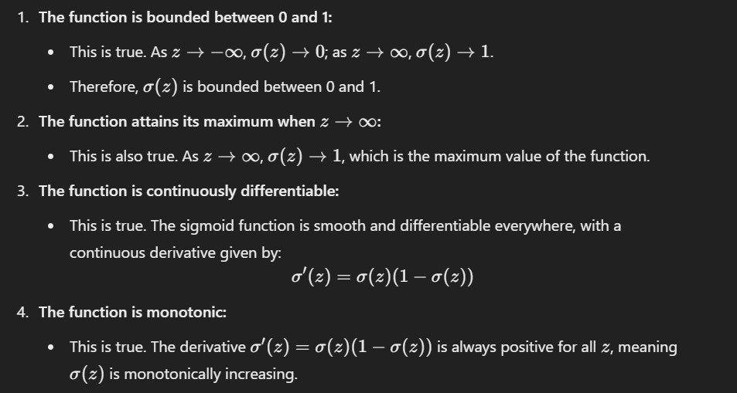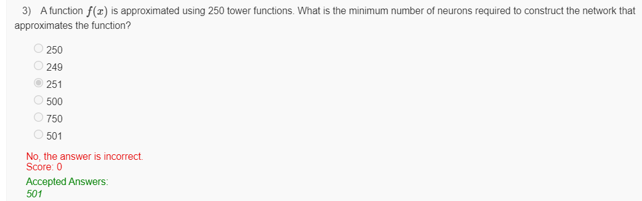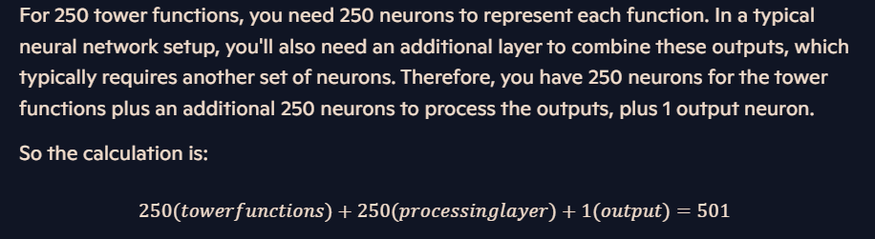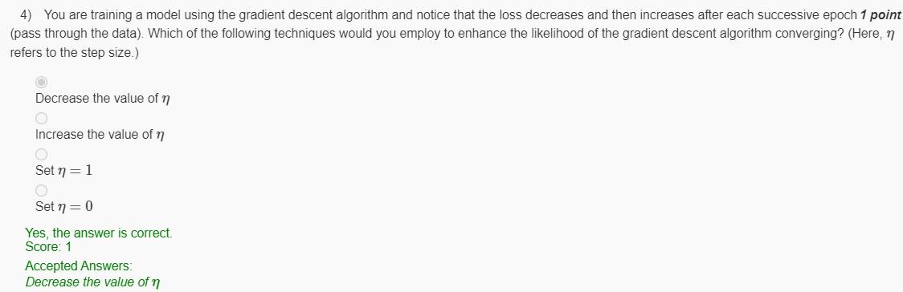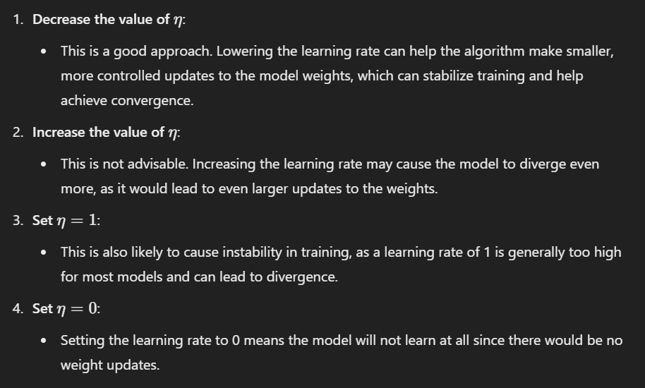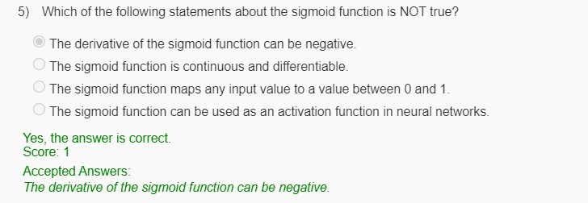

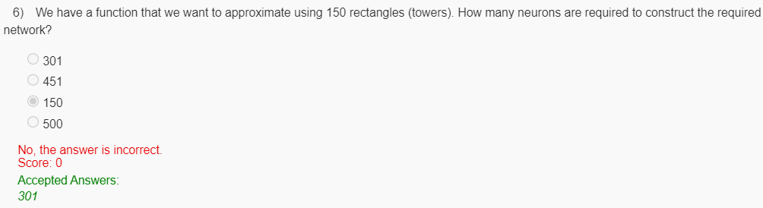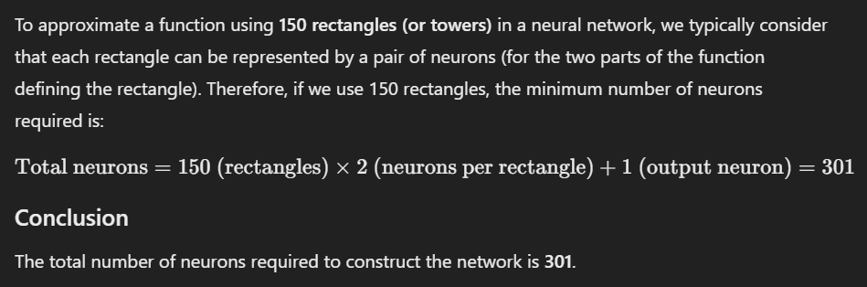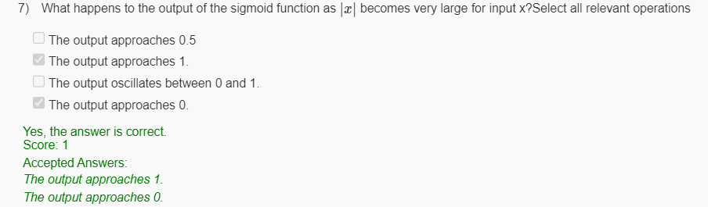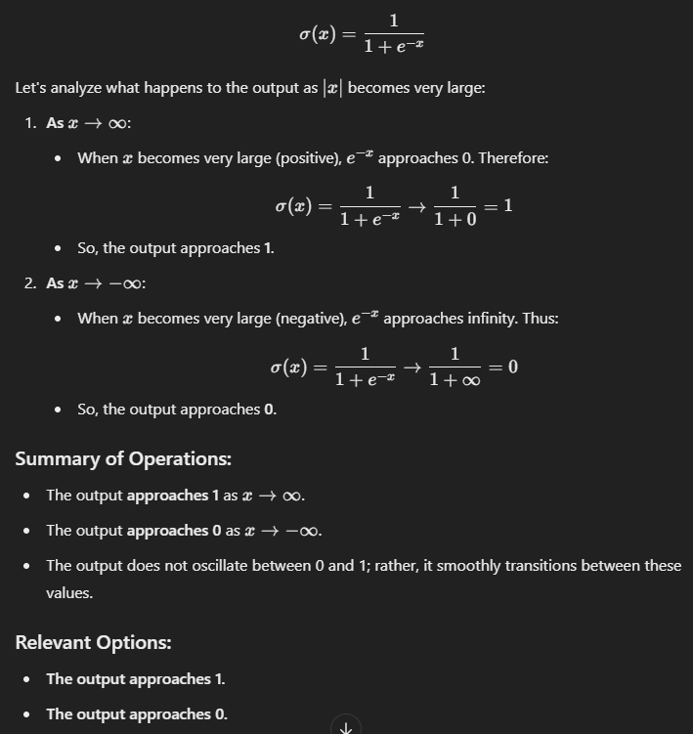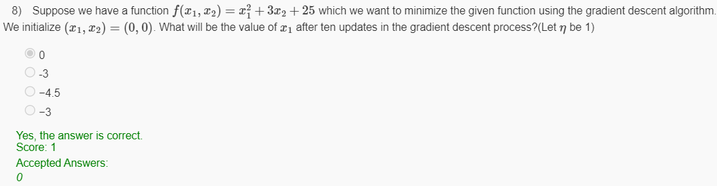

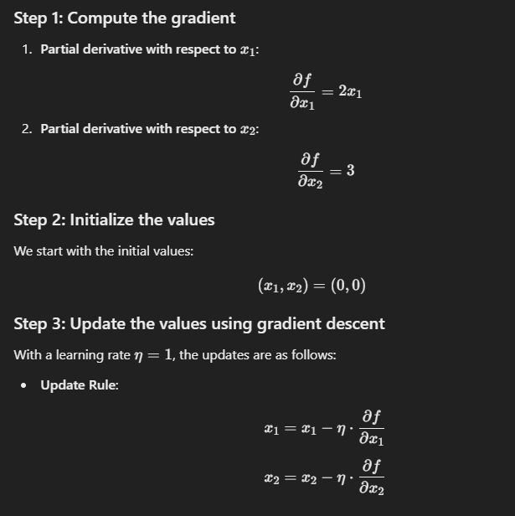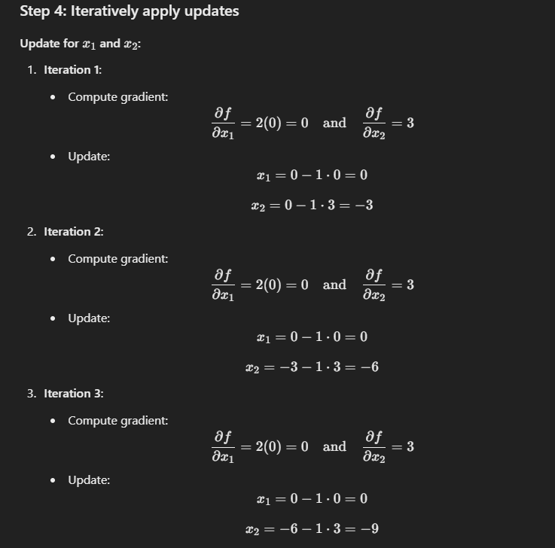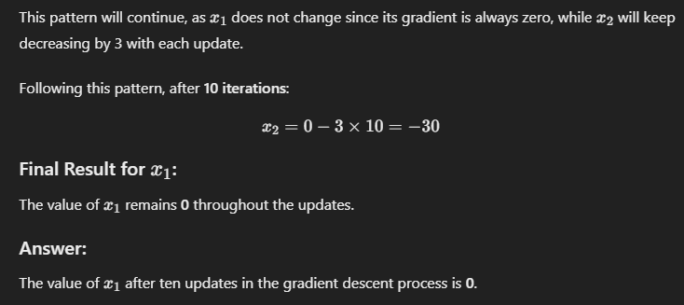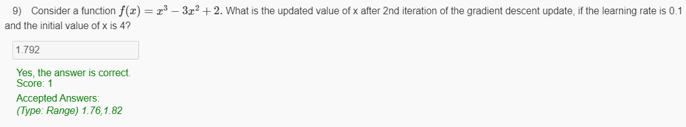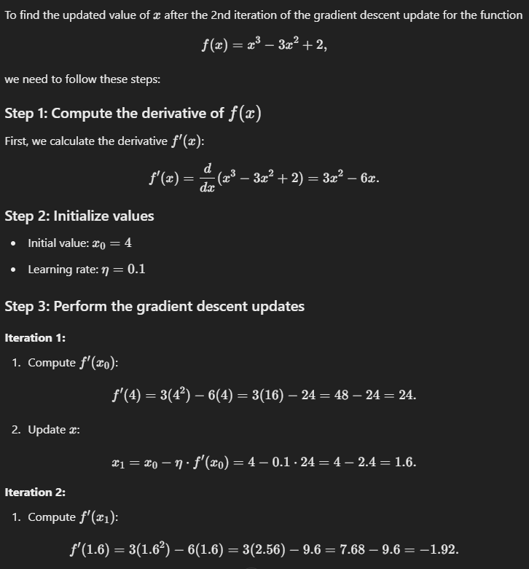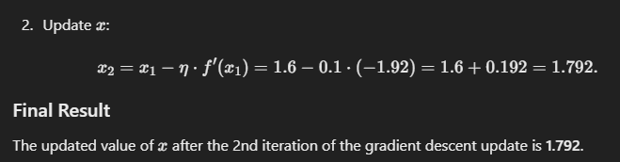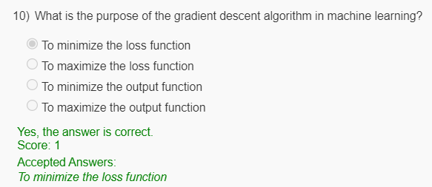

**Question 1:**

1. How many weights does a neural network have if it consists of an input layer with 2 neurons, three hidden layers each with 4 neurons, and an output layer with 2 neurons? Assume there are no bias terms in the network.

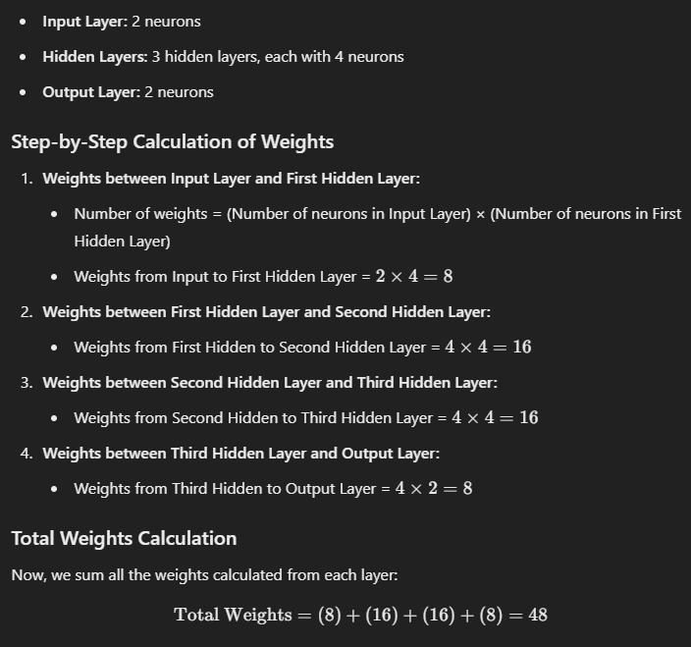

**Question 2:**

Suppose we have a Multi-layer Perceptron with an input layer, one hidden layer, and an output layer. The hidden layer contains 64 perceptrons. The output layer contains one perceptron. Choose the statement(s) that are true about the network.

**Options:**

* The network is capable of implementing 2^64 Boolean functions
* The network is capable of implementing 2^6 Boolean functions
* Each perceptron in the hidden layer can take in only 64 Boolean inputs
* Each perceptron in the hidden layer can take in only 6 Boolean inputs

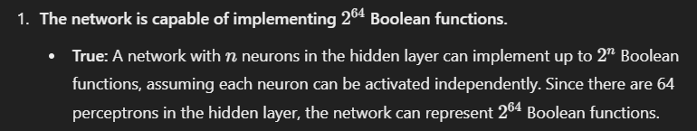

Question 3:

Consider a function f(x) = x^3 - 4x^2 + 7. What is the updated value of x after the 2nd iteration of the gradient descent update, if the learning rate is 0.1 and the initial value of x is 5?

